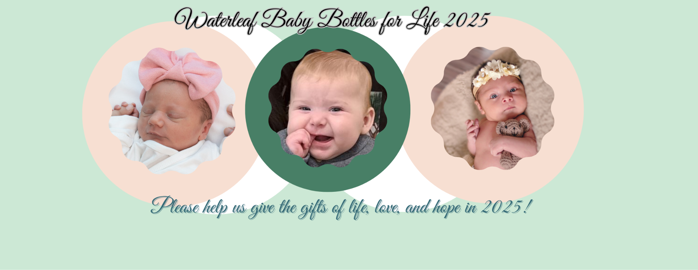
Baby Bottles for Life Campaign Steps 2025
STEP 1: Pick Up/Delivered Campaign Materials
Team leaders will pick up your church’s campaign materials or have them delivered two to three weeks prior to your church/organization’s distribution weekend. These materials include the following:
- Bottles with containers and/or Waterleaf envelopes/cards, coin bags, team instruction, and guidelines for running a campaign. Teams may also request a link to Waterleaf’s online fundraising page https://secure.qgiv.com/for/waterleafbabybottlesforlifecampaign2025 to collect donations online as well.

STEP 2: Publicize your Campaign
Team leaders will use the link https://onechoiceonelife.org/waterleaf-baby-bottles-for-life-2025/ to download all promotionalmaterials, including bulletin and pulpit announcements, posters, social media posts, and a Waterleaf Women’s Center Informational Slideshow Deck. Once downloaded, please customize with any additional information needed for your campaign.

There will also be a QR code that links directly to the online giving platform Qgiv- https://secure.qgiv.com/for/waterleafbabybottlesforlifecampaign2025 for your team fundraising page to add to your bulletin and poster. Team leaders should ultimately decide the best way to publicize your campaign.

STEP 3: Distribute the Bottles and/or Envelopes
During your BB4L distribution weekend, have your team of volunteers distribute the bottles and/or envelopes/cards after each service. Each weekend during your campaign, remind your congregation that you will be collecting the bottles and/or envelopes to support Waterleaf on the appointed collection weekend. This can continuously be done by speaking at services or through your church’s bulletin, newsletter, or website.

STEP 4: Gather Bottles and/or Envelopes
On the final weekend (collection weekend) of your campaign, have your BB4L team collect the filled bottles and/or envelopes before and after services. Allow a few weeks of collection after this date to collect more bottles.

STEP 5: Organize the Donations
Organize your team of BB4L volunteers to empty the bottles and/or envelopes and separate the change, cash, and checks. The change is placed into a coin bag provided by Waterleaf, and along with the cash deposited directly into your church’s bank account. The team leader then brings one check written for the cash/change and any other checks written out to Waterleaf along with the empty bottles and bins back to Waterleaf. We are happy to come and pick up the bottles and check(s)
if that is more convenient. Please call Megan Barnhart at 630-701-6270 for any questions or concerns.

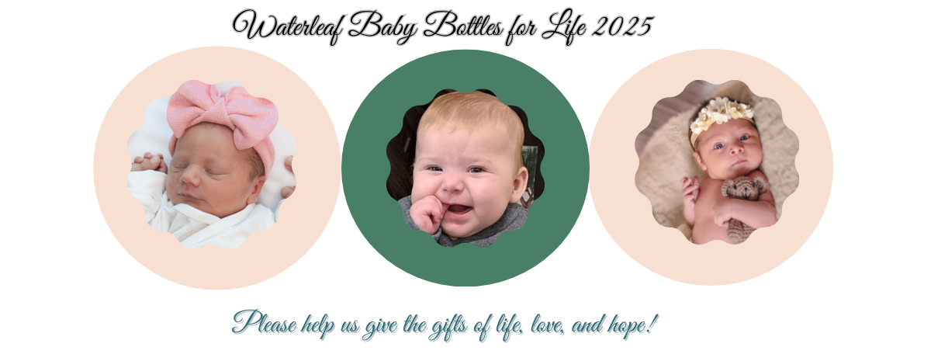

Waterleaf BB4L Campaign Steps
Step 1: Set Campaign Dates  Distribution Date: __________________  Collection Date:_____________________ | Step 2: Pick Up Campaign Materials  Date Acquired:__________________________  - ______# Baby Bottles  - ______# Envelopes/Cards  - ______# Cash Bags  ______ Team BB4L Instructions/Guidelines

Step 3: Publicize Your Campaign  - Go to https://onechoiceonelife.org/waterleaf-baby-bottles-for-life-2024/ for the following…  - Announcement for pulpit  - Announcement for bulletin/newsletter/website  - Promotional Posters  - Step by Step Checklist  - Waterleaf Women’s Center Slideshow Deck  - Add QR Code for online fundraising Qgiv  https://secure.qgiv.com/for/babyfottlesforlifecampaign | Step 4: Distribute Bottles/Envelopes  - Develop team member distribution sign up  - Distribute bottles/envelopes/cards at parish

Step 5: Collect Filled Bottles/Envelopes  - Develop team member collection sign up  - Collect all bottles/envelopes  - Place bottles/envelopes in secure location until donations are processed | Step 6: Process Donations  - Empty bottles/envelopes  - Separate cash/coins/checks  - Place coins in coin bags  - Organize cash(dollars) by amount  - Deposit coins/cash into church bank account  - Write check to Waterleaf for total coins/cash amount deposited

Step 7: Return Materials & Donations to Waterleaf  Date Returned:______________________________  - _____ #Empty bottles  - _____ # Filled bottles (returned later)  - _____ #Checks (Made out to Waterleaf)  - _____ Final Donation Amount Total  - Coins/Cash $___________  - Checks $ ___________ | Step 8: Post Campaign Update (Waterleaf Staff Completes)  - Thank you Letter -Pastor  - Thank you Letter -Team Leader  - Thank you Announcement Bulletin/Newsletter/Website

