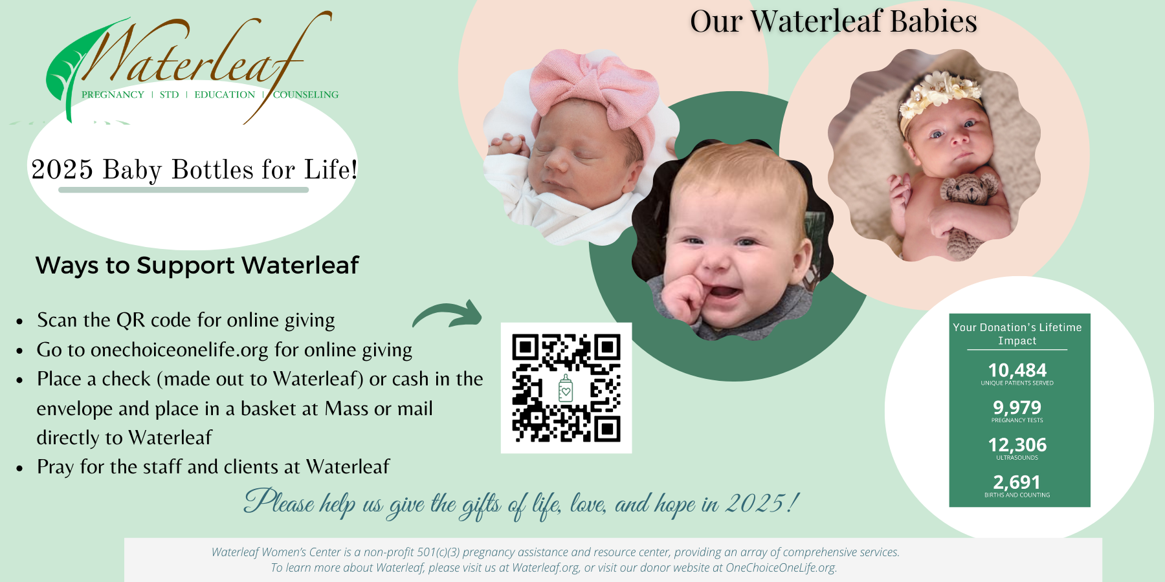
Insert Start date here
Insert End date here
Insert Parish Name Here

