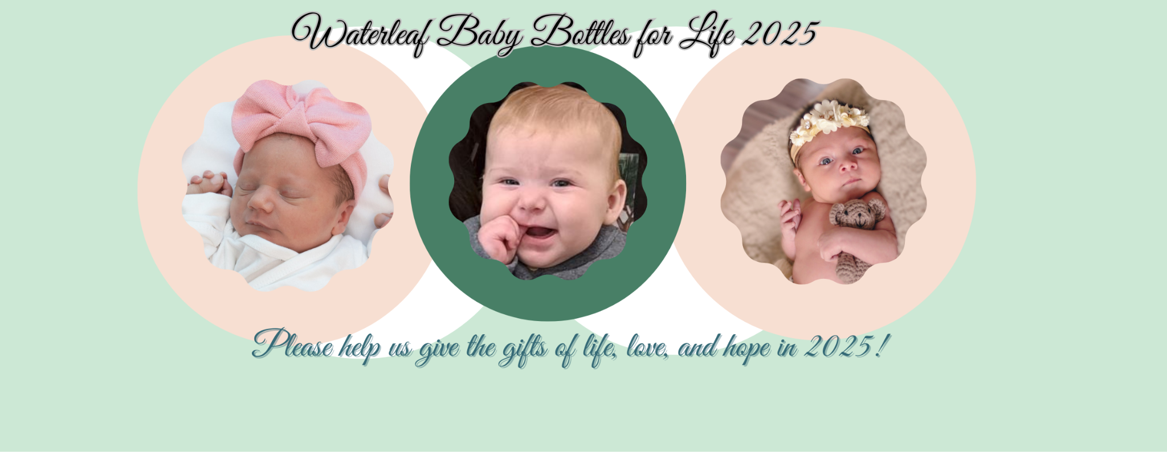

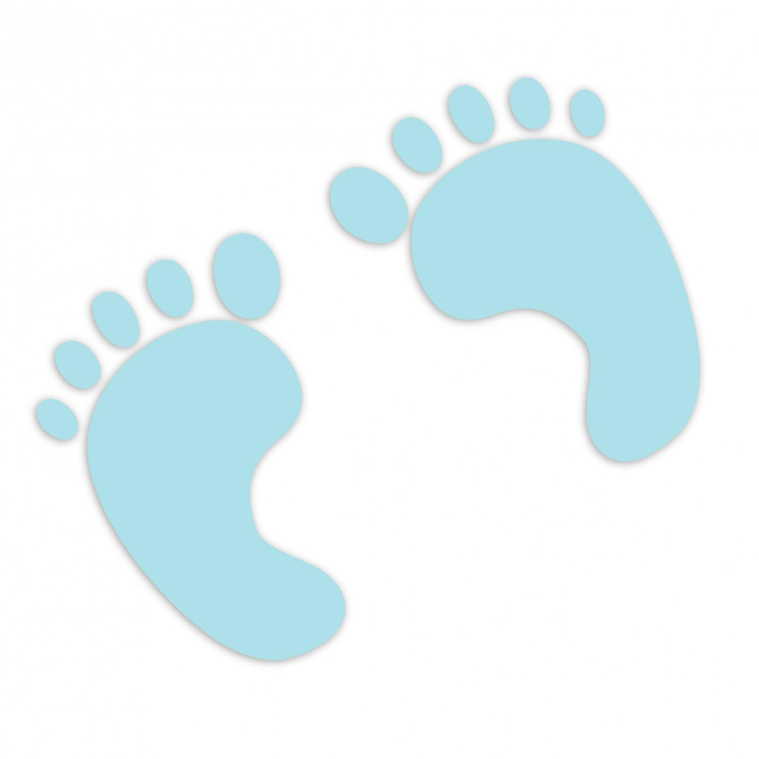**Baby Bottles for Life Campaign Steps 2025**

**STEP 1: Pick Up/Delivered Campaign Materials**

Team leaders will pick up your church’s campaign materials or have them delivered two to three weeks prior to your church/organization’s distribution weekend. These materials include the following:

* Bottles with containers and/or Waterleaf envelopes/cards, coin bags, team instruction, and guidelines for running a campaign. Teams may also request a link to Waterleaf’s online fundraising page <https://secure.qgiv.com/for/waterleafbabybottlesforlifecampaign2025> to collect donations online as well.

**STEP 2: Publicize your Campaign**

Team leaders will use the link [***https://onechoiceonelife.org/waterleaf-baby-bottles-for-life-2025/***](https://onechoiceonelife.org/waterleaf-baby-bottles-for-life-2024/) to download all promotionalmaterials, including bulletin and pulpit announcements, posters, social media posts, and a Waterleaf Women’s Center Informational Slideshow Deck. Once downloaded, please customize with any additional information needed for your campaign.

There will also be a QR code that links directly to the online giving platform ***Qgiv-*** <https://secure.qgiv.com/for/waterleafbabybottlesforlifecampaign2025> *for your* team fundraising page to add to your bulletin and poster. Team leaders should ultimately decide the best way to publicize your campaign.

**STEP 3: Distribute the Bottles and/or Envelopes**

During your BB4L distribution weekend, have your team of volunteers distribute the bottles and/or envelopes/cards after each service. Each weekend during your campaign, remind your congregation that you will be collecting the bottles and/or envelopes to support Waterleaf on the appointed collection weekend. This can continuously be done by speaking at services or through your church’s bulletin, newsletter, or website.

**STEP 4: Gather Bottles and/or Envelopes**

On the final weekend (collection weekend) of your campaign, have your BB4L team collect the filled bottles and/or envelopes before and after services. Allow a few weeks of collection after this date to collect more bottles.

**STEP 5: Organize the Donations**

Organize your team of BB4L volunteers to empty the bottles and/or envelopes and separate the change, cash, and checks. The change is placed into a coin bag provided by Waterleaf, and along with the cash deposited directly into your church’s bank account. The team leader then brings one check written for the cash/change and any other checks written out to *Waterleaf* along with the empty bottles and bins back to Waterleaf. We are happy to come and pick up the bottles and check(s)

if that is more convenient. **Please call Megan Barnhart at 630-701-6270 for any questions or concerns.**

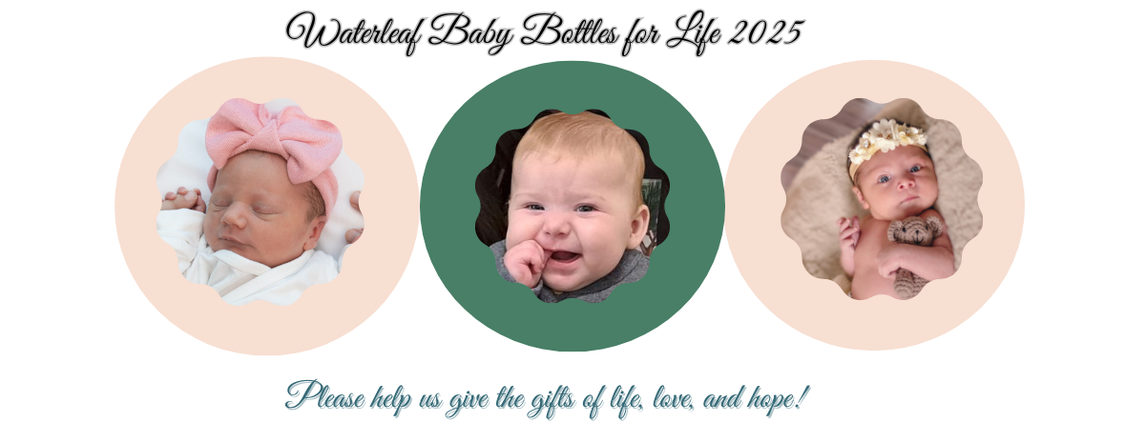

 Waterleaf BB4L Campaign Steps**

| **Step 1: Set Campaign Dates**  Distribution Date: __________________  Collection Date:_____________________ | **Step 2: Pick Up Campaign Materials**  Date Acquired:__________________________   * ______# Baby Bottles * ______# Envelopes/Cards * ______# Cash Bags   ______ Team BB4L Instructions/Guidelines |
| --- | --- |

| **Step 3: Publicize Your Campaign**   * Go to [https://onechoiceonelife.org/waterleaf-baby-bottles-for-life-2024/](https://onechoiceonelife.org/waterleaf-baby-bottles-for-life-2022/) for the following… * Announcement for pulpit * Announcement for bulletin/newsletter/website * Promotional Posters * Step by Step Checklist * Waterleaf Women’s Center Slideshow Deck * Add QR Code for online fundraising Qgiv   <https://secure.qgiv.com/for/babyfottlesforlifecampaign> | **Step 4: Distribute Bottles/Envelopes**   * Develop team member distribution sign up * Distribute bottles/envelopes/cards at parish |
| --- | --- |

| **Step 5: Collect Filled Bottles/Envelopes**   * Develop team member collection sign up * Collect all bottles/envelopes * Place bottles/envelopes in secure location until donations are processed | **Step 6: Process Donations**   * Empty bottles/envelopes * Separate cash/coins/checks * Place coins in coin bags * Organize cash(dollars) by amount * Deposit coins/cash into church bank account * Write check to *Waterleaf* for total coins/cash amount deposited |
| --- | --- |

| **Step 7: Return Materials & Donations to Waterleaf**  Date Returned:______________________________   * _____ #Empty bottles * _____ # Filled bottles (returned later) * _____ #Checks *(Made out to Waterleaf)* * *_____* Final Donation Amount Total * Coins/Cash $___________ * Checks $ ___________ | **Step 8: Post Campaign Update (Waterleaf Staff Completes)**   * Thank you Letter -Pastor * Thank you Letter -Team Leader * Thank you Announcement Bulletin/Newsletter/Website |
| --- | --- |