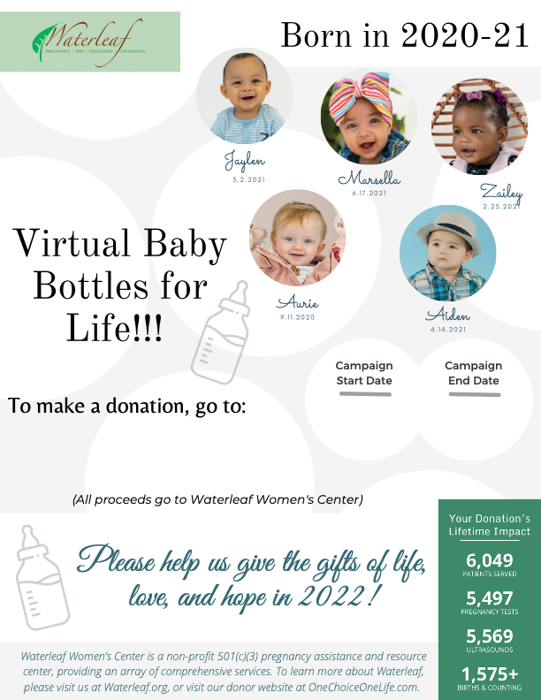

<https://waterleafwomenscenter-bloom.kindful.com/causes>

<Insert church logo here>

<Insert date & time here>

<Insert date & time here>