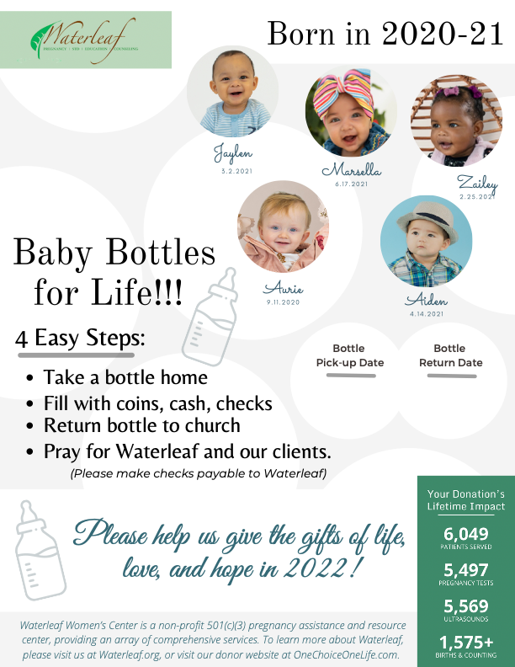

<Insert church logo here>

<Insert date & time here>

<Insert date & time here>